SQL ASSIGNMENT 1

Avinash A Godi



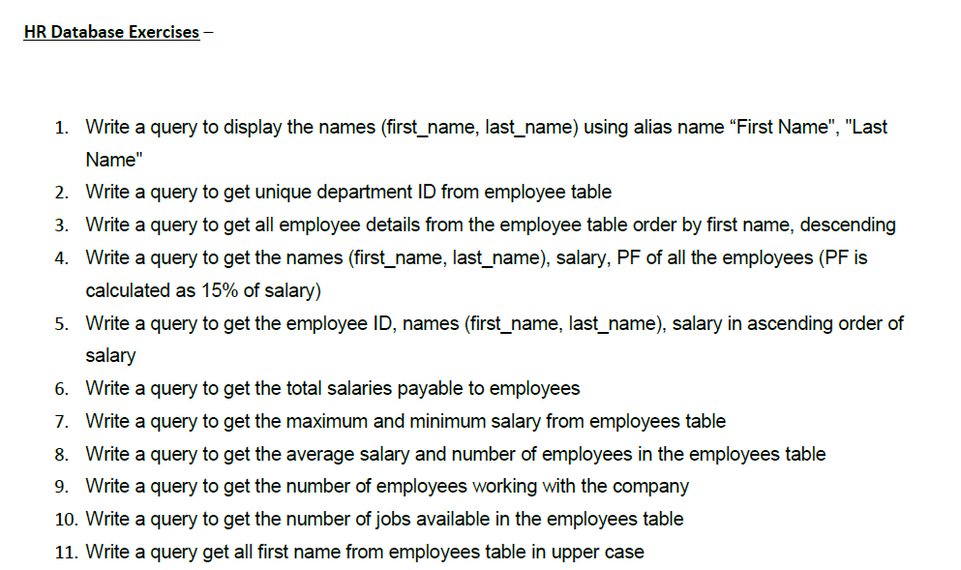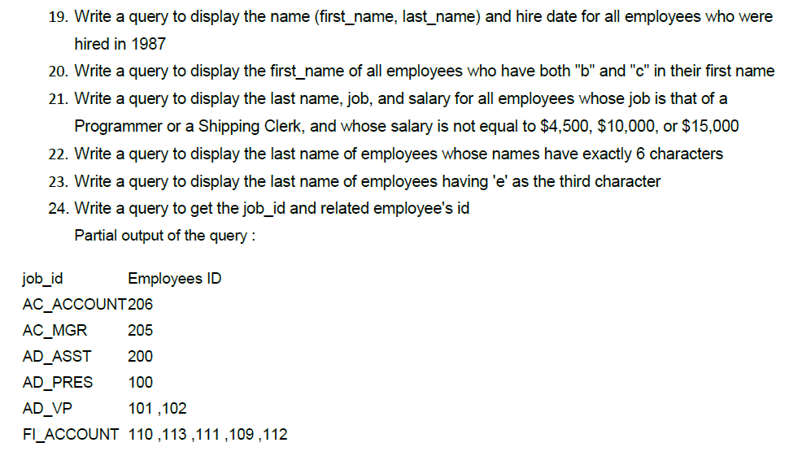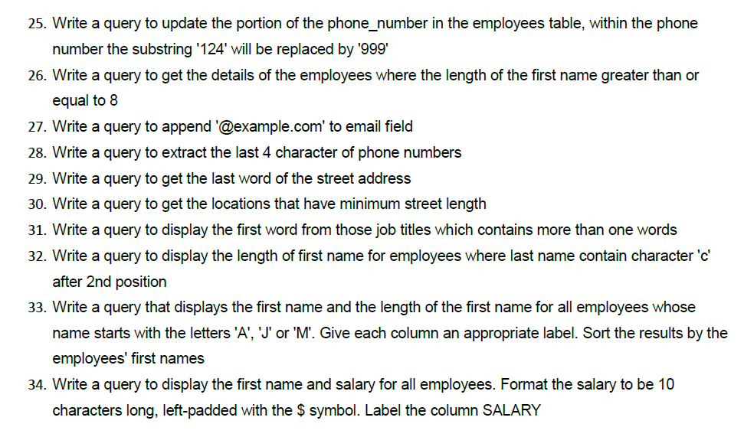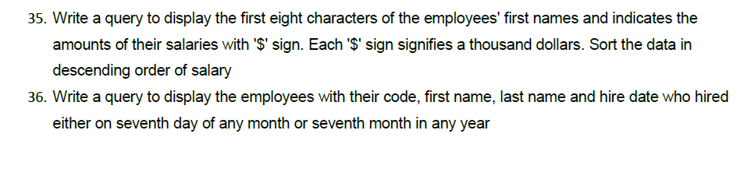

---- Hr database Exercises ----

/* 1 Write a query to display the names (first_name, last_name) using alias name “First Name", "Last Name" */

Select first_name as "First Name", last_name as "Last Name" from hr.employees;

/* 2 Write a query to get unique department ID from employee table */

select distinct(department_id) from hr.employees where department_id is not null;

/* 3 Write a query to get all employee details from the employee table order by first name, descending */

select * from hr.employees order by first_name desc;

/* 4 Write a query to get the names (first_name, last_name), salary, PF of all the employees (PF is calculated as 15% of salary) */

select concat(first_name," ",last_name) as "Name", salary, salary* 0.15 as "PF" from hr.employees;

/* 5 Write a query to get the employee ID, names (first_name, last_name), salary in ascending order of salary */

select employee_id, concat(first_name," ",last_name) as "Name", salary from hr.employees order by salary;

/* 6 Write a query to get the total salaries payable to employees */

select sum(salary) as "Total Salary" from hr.employees;

/* 7 Write a query to get the maximum and minimum salary from employees table */

select max(salary) as "Maximun Salary", min(salary) as "Minimum Salary" from hr.employees;

/* 8 Write a query to get the average salary and number of employees in the employees table */

select round(avg(salary),3) as "Average Salary", count(*) as "No. of Employees" from hr.employees;

/* 9 Write a query to get the number of employees working with the company */

select count(*) as "No. of Employees" from hr.employees;

/* 10 Write a query to get the number of jobs available in the employees table */

select count(distinct(job_id)) as "No. of Jobs" from hr.employees;

/* 11 Write a query get all first name from employees table in upper case */

select upper(first_name) as "First Name" from hr.employees;

/* 12 Write a query to get the first 3 characters of first name from employees table */

select substring(first_name,1,3) as "First 3 characters of first name" from hr.employees;

/* 13 Write a query to get first name from employees table after removing white spaces from both side */

select trim(first_name) from hr.employees;

/* 14 Write a query to get the length of the employee names (first_name, last_name) from employees table */

select first_name as "First Name", last_name as "Last Name", length(first_name)+length(last_name) as "Length of Name" from hr.employees;

/* 15 Write a query to check if the first_name fields of the employees table contains numbers */

select * from hr.employees where first_name regexp '[0-9]';

/* 16 Write a query to display the name (first_name, last_name) and salary for all employees whose salary is not in the range $10,000 through $15,000 */

select concat(first_name," ",last_name) as "Name", salary from hr.employees where salary not between 10000 and 15000;

/* 17 Write a query to display the name (first_name, last_name) and department ID of all employees in departments 30 or 100 in ascending order */

select concat(first_name," ",last_name) as "Name", department_id from hr.employees where department_id = 30 or department_id = 100 order by department_id;

/* 18 Write a query to display the name (first_name, last_name) and salary for all employees whose salary is not in the range $10,000 through $15,000 and are in department 30 or 100 */

select concat(first_name," ",last_name) as "Name", salary, department_id from hr.employees where salary not between 10000 and 15000 and department_id = 30 or department_id = 100;

/* 19 Write a query to display the name (first_name, last_name) and hire date for all employees who were hired in 1987 */

select concat(first_name," ",last_name) as "Name", hire_date as "Hire Date" from hr.employees where year(hire_date) = 1987;

/* 20 Write a query to display the first_name of all employees who have both "b" and "c" in their first name */

select first_name from hr.employees where first_name like '%b%c%';

/* 21 Write a query to display the last name, job, and salary for all employees whose job is that of a Programmer or a Shipping Clerk, and whose salary is not equal to $4,500, $10,000, or $15,000*/

select last_name, job_id, salary from hr.employees where job_id = 'IT_PROG' or job_id = 'SH_CLERK' and salary not in(4500,10000,15000);

/* 22 Write a query to display the last name of employees whose names have exactly 6 characters */

select last_name as "Name" from hr.employees where length(last_name) = 6;

/* 23 Write a query to display the last name of employees having 'e' as the third character */

select last_name as 'Name' from hr.employees where last_name like '__e%';

/* 24. Write a query to get the job_id and related employee's id */

select job_id as "Job ID", group_concat(employee_id) as "Employee ID" from hr.employees group by job_id;

/* 25 Write a query to update the portion of the phone_number in the employees table,

within the phone number the substring '124' will be replaced by '999'*/

update hr.employees set phone_number = replace(phone_number, '124', '999') where phone_number like '%124%';

/* 26 Write a query to get the details of the employees where the length of the first name greater than or equal to 8 */

select * from hr.employees where length(first_name) >= 8;

/* 27 Write a query to append '@example.com' to email field */

update hr.employees set email = concat(email,'@example.com');

select concat(lower(email),'@example.com') as "email" from hr.employees;

/* 28 Write a query to extract the last 4 character of phone numbers */

select right(phone_number,4) as "Phone Number" from hr.employees;

/* 29 Write a query to get the last word of the street address */

select street_address, substring_index(rtrim(street_address), ' ', -1) as "Last word of street address" from hr.locations;

/* 30 Write a query to get the locations that have minimum street length */

select * from hr.locations where length(street_address) <= (select min(length(street_address)) from hr.locations);

/* 31 Write a query to display the first word from those job titles which contains more than one words */

select job_title, substr(job_title,1, instr(job_title, ' ')-1) from hr.jobs;

/* 32 Write a query to display the length of first name for employees where last name contain character 'c' after 2nd position */

select first_name as 'First Name', last_name as 'Last Name', length(first_name) as 'Length of First Name' from hr.employees where last_name like '__%c%';

/* 33 Write a query that displays the first name and the length of the first name for all employees whose name starts with the letters 'A', 'J' or 'M'. Give each column an appropriate label. Sort the results by the employees' first names */

select first_name as 'First Name', length(first_name) as 'Length of First Name' from hr.employees where first_name like 'A%' or first_name like 'J%' or first_name like 'M%' order by first_name;

/* 34 Write a query to display the first name and salary for all employees. Format the salary to be 10 characters long, left-padded with the $ symbol. Label the column SALARY */

select first_name as "First Name", lpad(salary,10,'$') as 'Salary' from hr.employees;

/* 35 Write a query to display the first eight characters of the employees' first names and indicates the amounts of their salaries with '$' sign. Each '$' sign signifies a thousand dollars. Sort the data in descending order of salary */

select left(first_name,8) as 'First Name', repeat('$', floor(salary/1000)) as 'Salary in $', salary

from hr.employees;

/* 36 Write a query to display the employees with their code, first name, last name and hire date who hired either on seventh day of any month or seventh month in any year */

select employee_id as 'ID', first_name as 'First Name', last_name as 'Last Name', hire_date as 'Hire Date' from hr.employees where hire_date like '%-%-07' or hire_date like '%-07-%';

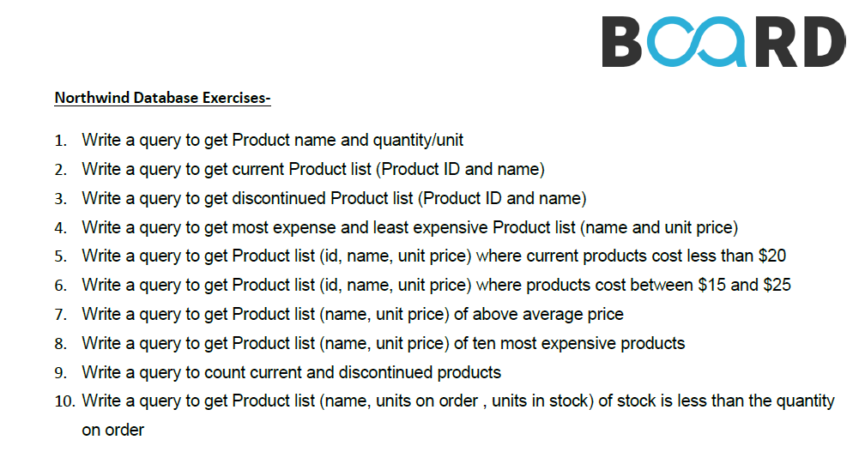

---- Northwind Database Exercises ----

/* 1 Write a query to get Product name and quantity/unit */

select ProductName as 'Product name', QuantityPerUnit as 'Quantity/unit' from northwind.products;

/* 2 Write a query to get current Product list (Product ID and name) */

select concat(ProductID, ' : ', ProductName) as 'Current Product List' from northwind.products

where Discontinued = 0 order by ProductName;

/* 3 Write a query to get discontinued Product list (Product ID and name) */

select concat(ProductID, ' : ', ProductName) as ' Discontinued Product List' from northwind.products where Discontinued = 1 order by ProductName;

/* 4 Write a query to get most expense and least expensive Product list (name and unit price) */

select ProductName as 'Product Name', round(UnitPrice,2) as 'Expenses' from northwind.products order by UnitPrice desc;

/* 5 Write a query to get Product list (id, name, unit price) where current products cost less than $20 */

select ProductID, ProductName, round(UnitPrice,2) as 'Price' from northwind.products

where Discontinued = 0 and UnitPrice <20 order by UnitPrice desc;

/* 6 Write a query to get Product list (id, name, unit price) where products cost between $15 and $25 */

select ProductID, ProductName, round(UnitPrice,2) as 'Price' from northwind.products

where UnitPrice between 15 and 25 and Discontinued = 0 order by UnitPrice desc;

/* 7 Write a query to get Product list (name, unit price) of above average price */

select distinct(ProductName) as 'Product Name', round(UnitPrice,2) as 'Unit Price' from northwind.products where UnitPrice > (select avg(UnitPrice) from northwind.products)

order by UnitPrice;

/* 8 Write a query to get Product list (name, unit price) of ten most expensive products */

select distinct(ProductName) as 'Ten most expensive products', round(UnitPrice,2) as 'Unit Price' from northwind.products order by UnitPrice desc limit 10;

/*9 Write a query to count current and discontinued products */

select count(ProductName) as "Product", Discontinued from northwind.products group by Discontinued;

/* 10 Write a query to get Product list (name, units on order , units in stock) of stock is less than the quantity on order */

select ProductName as 'Product Name', UnitsOnOrder, UnitsInStock from northwind.products where discontinued = 0 and UnitsInStock < UnitsOnOrder;